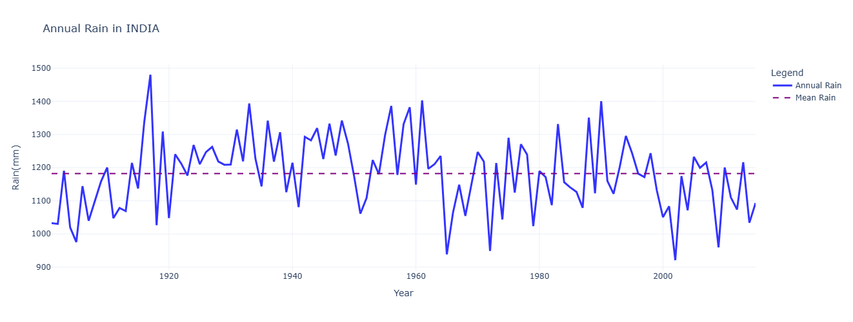
This graph shows significant year-to-year variability in India’s annual rainfall, with no apparent long-term upward or downward trend over the century. The red dashed line indicates the mean rainfall, around which the annual rainfall oscillates. Notable peaks and troughs highlight extreme rainfall events and dry years.
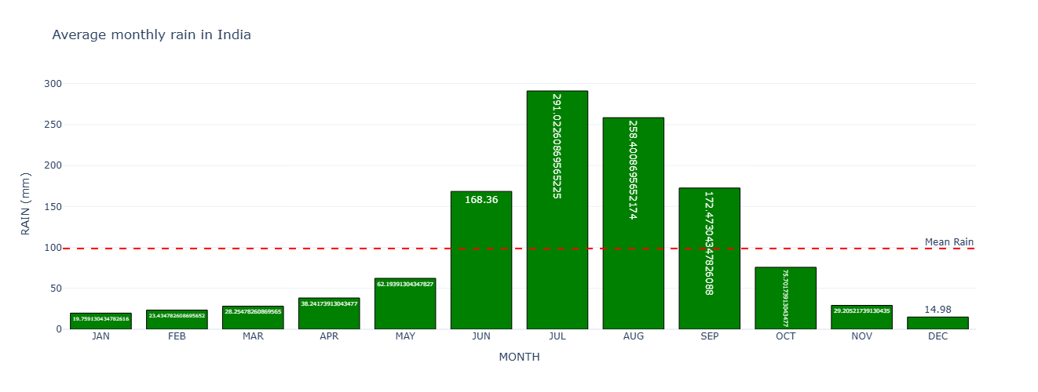This chart illustrates a highly uneven distribution of rainfall across months, July and August receive the highest average rainfall. The red dashed line represents the mean monthly rainfall, showing that most months receive rainfall below the average, except during the monsoon.
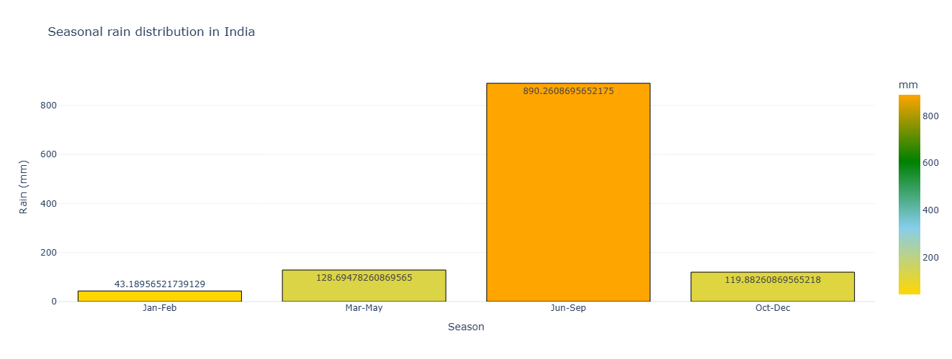The seasonal distribution highlights the dominance of the monsoon season contributing the bulk of annual rainfall around 890 mm). In contrast, the other seasons contribute significantly less to the annual total, which emphasizes the critical role of the monsoon.
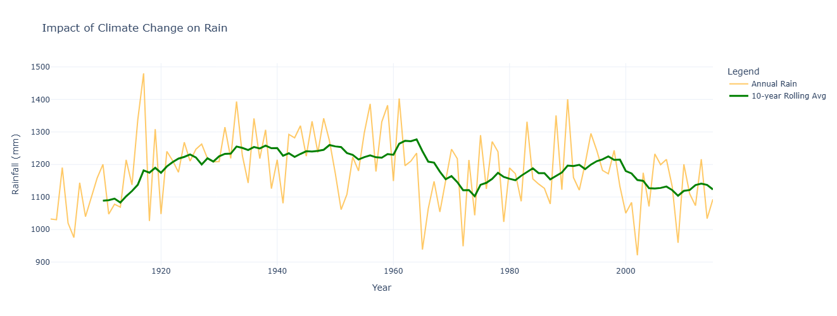This graph shows the annual rainfall trends in India (blue line) and a 10-year rolling average (red line) to identify long-term patterns. While annual rainfall exhibits significant variability, the 10-year rolling average indicates a slight downward trend post-1960, which suggests a possible impact of climate change on rainfall distribution. Periods of higher averages in the early 20th-century contrast with more consistent but lower averages in recent decades.
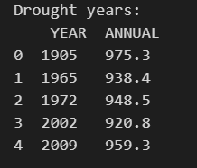
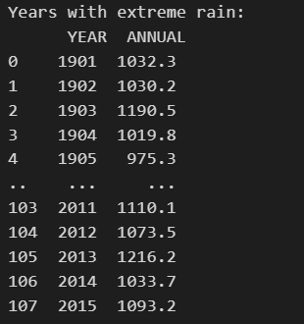
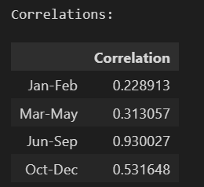

The analysis identifies five significant drought years (e.g., 2002 and 2009) and seven extreme rainfall years (e.g., 1917 and 1990) based on deviations from the mean annual rainfall. Seasonal rainfall correlations with annual totals reveal that the monsoon season (June-September) has the strongest correlation (0.93), which indicates it predominantly drives annual rainfall patterns.
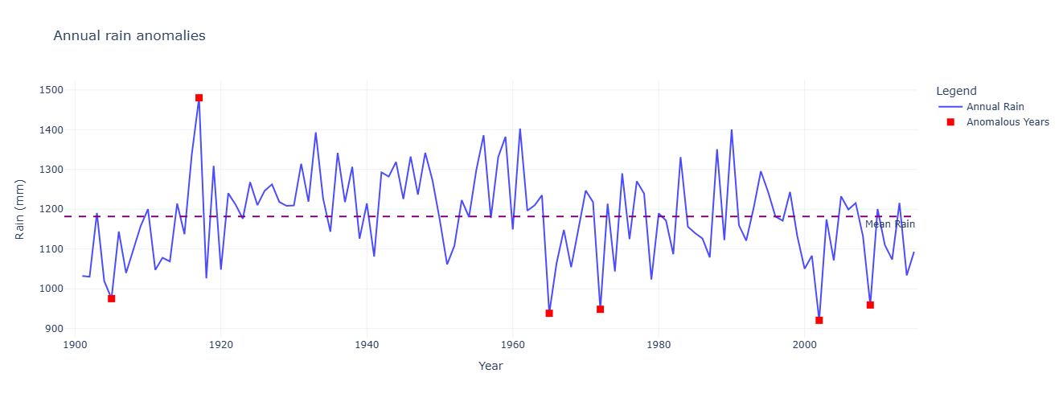
This graph highlights years with significant rainfall anomalies, where annual rainfall deviated substantially from the mean. Drought years (e.g., 1905, 1965, 2002) and extreme rainfall years (e.g., 1917, 1961) are marked as red points, which showcase outliers in rainfall patterns. While most years cluster around the mean (green dashed line), the anomalies emphasize the variability in India’s rainfall, driven by factors like monsoonal fluctuations and climate events.
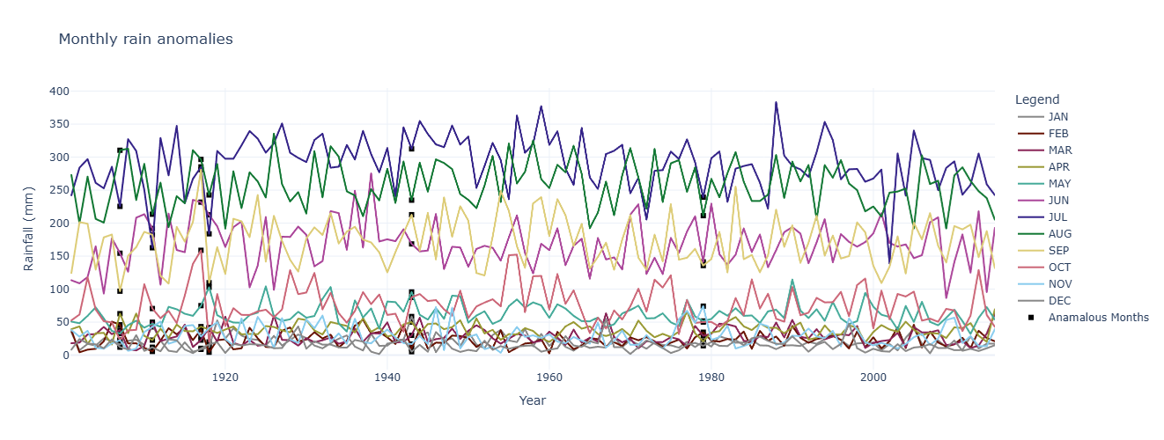Anomalies in non-monsoon months, while less frequent, highlight periods of unusual weather patterns, potentially linked to climate variability or regional disturbances. This graph supports the uneven distribution and high dependence on monsoonal rainfall for India’s water resources.
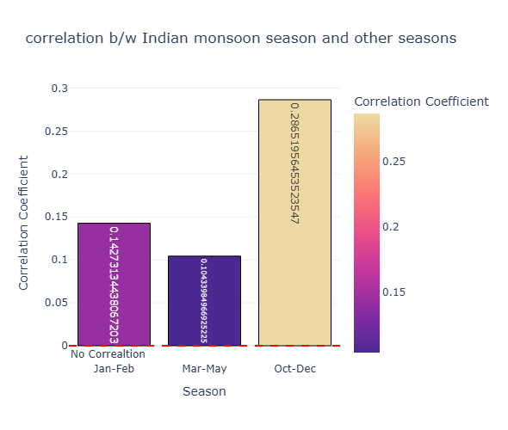
The October-December season has the highest correlation (0.29), which suggests a moderate relationship, possibly due to the post-monsoon retreat rains. The January-February (0.14) and March-May (0.10) seasons exhibit weaker correlations, which indicate minimal dependence on monsoon rainfall. This highlights the dominance of monsoon as an independent driver of India’s annual rainfall, with limited effects on other seasons.
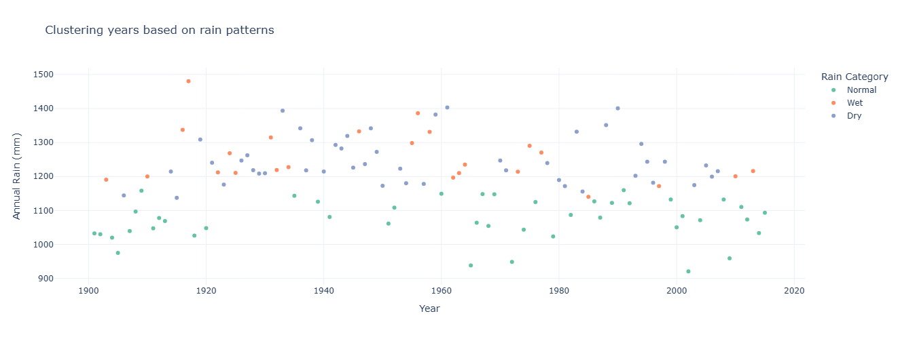
clusters reveal that most years fall into the Normal category, Wet years are irregularly distributed throughout the timeline, concentrated in the early and mid-20th century. Dry years are more frequent in the latter half, indicating a potential shift in rainfall patterns over time.
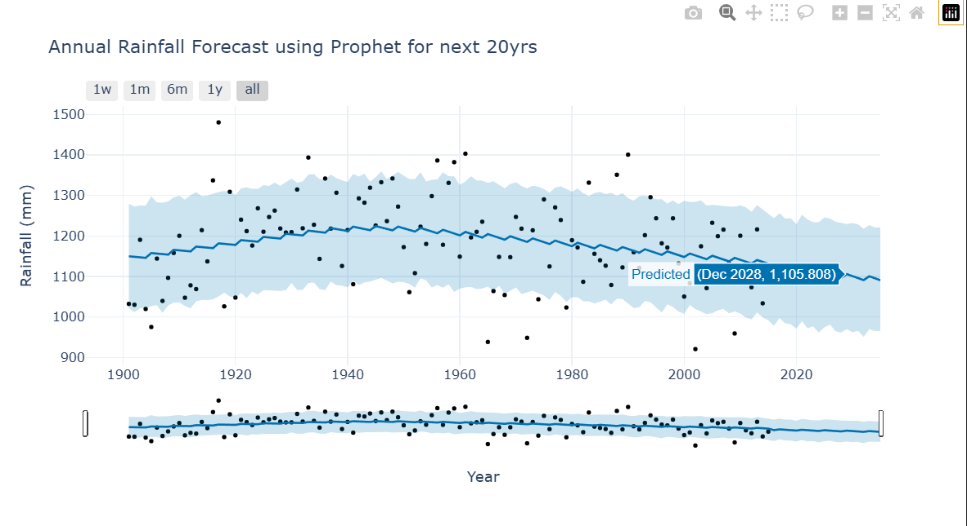
The blue line represents the model’s forecast trend, while the shaded area indicates the confidence interval, black dots representing the actual monthly data. The model captures the variability well but highlights that future rainfall may continue to slightly decrease, which emphasizes the need for adaptive strategies to manage potential water resource challenges.

